**Kempsville Academy, Inc. t/a**

**Barefoot Kids**

**Christian Day School**

**Est. 1993**

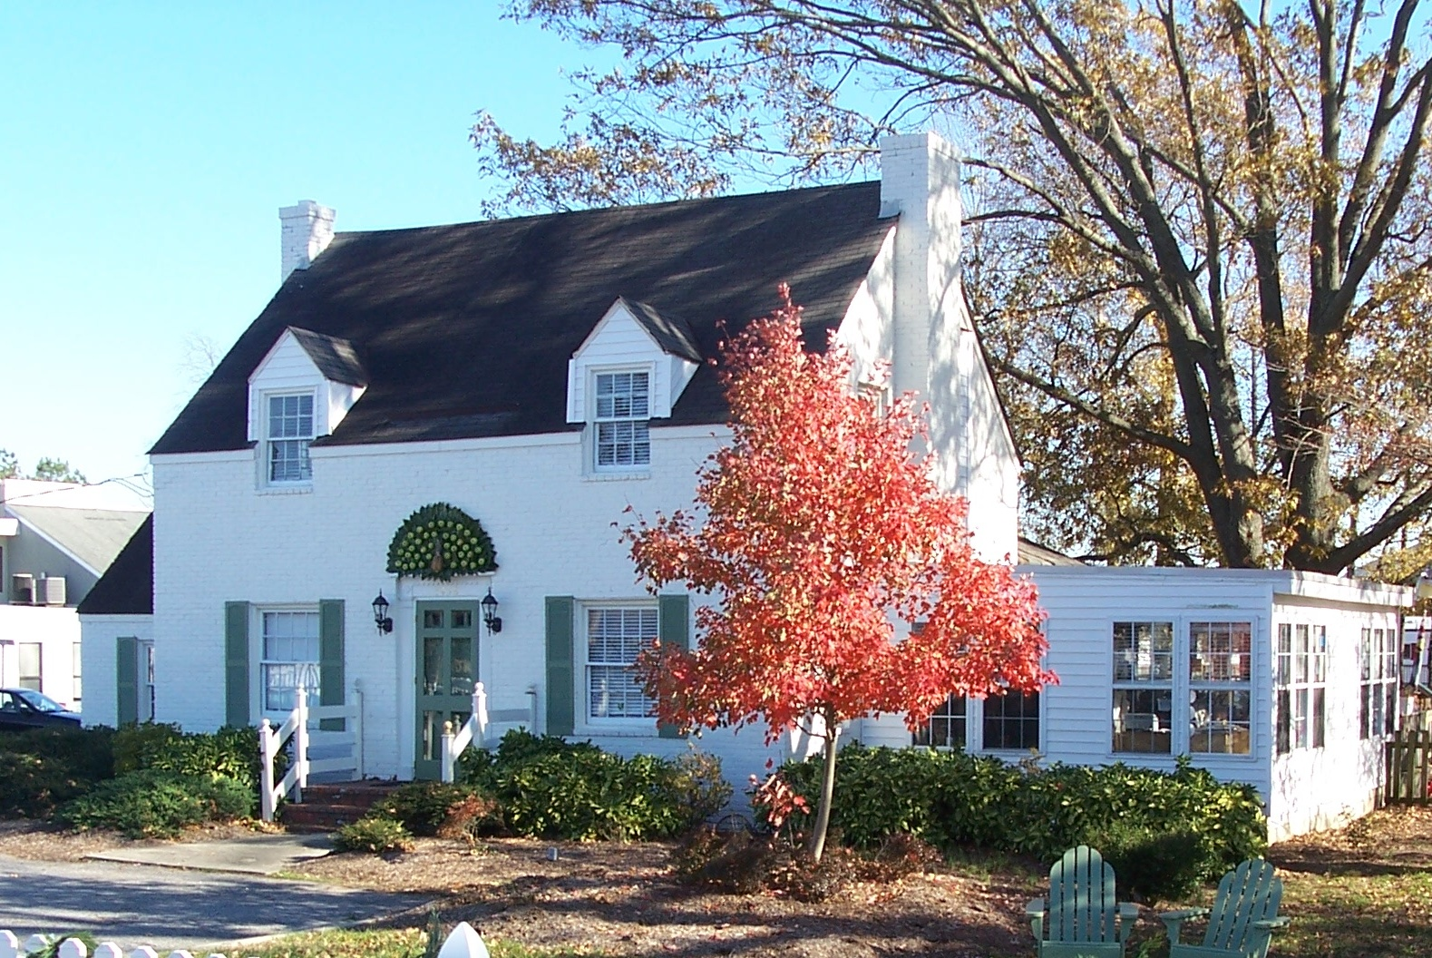

Footprints of Faith, Friendships & Fundamentals

1458 Kempsville Road

Virginia Beach, VA 23464-7302

757-467-1234 / (Fax) 757-467-5285

[www.BarefootKids.com](http://www.BarefootKids.com)

[BarefootKids@me.com](mailto:BarefootKids@me.com)

**Hours of Operation for Children *over* 24mos:**

6:45a.m – 6:00 p.m., Monday – Friday

**Hours of Operation for Children *under* 24mos:**

7:30a.m – 5:00 p.m., Monday - Friday

INTRODUCTION

Kempsville Academy, Inc. t/a Barefoot Kids, established in 1993, is a nondenominational Christian Day School that is licensed by the Commonwealth of Virginia Department of Social Services. Although many children attend Barefoot Kids we believe in small classes with quality standards. Barefoot Kids is open to all children from infancy to 10 years old, regardless of race, nationality or creed, who may benefit from our type of program.

MISSION

**Barefoot Kids** exists to form a partnership with families, to provide an environment in which children will develop Christian character, self esteem, and readiness for school and other life experiences through developmentally appropriate activities and biblical foundations to equip them to impact the world for Christ.

VISION

The vision of **Barefoot Kids** is to develop leaders who stand firm in biblical and academic foundations and are equipped to impact the world for Christ.

SCHOOL CALENDAR

Please visit www.BarefootKids.com for a copy of our school calendar, including school closings. In case of inclement weather, closings, or emergency procedures, please call Barefoot Kids or visit us at [www.BarefootKids.com](http://www.BarefootKids.com). In the event that Barefoot Kids cannot be reached, we will follow the Virginia Beach Public School System.

PHILOSOPHY

*Train a child in the way he should go;*

*and when he is old, he will not turn from it. Proverbs 22:6*

God has given parents and teachers the awesome responsibility of nurturing the children He has placed in our care. When parents must work, now more than ever, it is essential that children be cared for in a Christian environment by dedicated teachers. Therefore, we exist to form a partnership with parents to provide an environment in which children can develop wholesome self-images. We believe that as children explore, question, listen, build, paint, play and sing they develop readiness for school and other life experiences. Furthermore, we believe that the quality of these early experiences will have a profound influence on each child. We want each child to realize his/her full potential while developing Christian character and high self-esteem in a positive learning environment. We believe that by recognizing and supporting each child’s individual talents and interests we can instill a lifelong love of learning. We believe that the Bible is the basis of wisdom and we will endeavor to teach Biblical truths by example and through Bible stories and character studies without any specific doctrinal bias.



**BAREFOOT KIDS**

**ESTABLISHED LINES OF AUTHORITY**

**Administrator**

Kathleen S. Barefoot

**Program Director**

Jenifer Barefoot Hixenbaugh

**Director of Staff & Supervision**

**Teachers**

**Aides**

Licensing information can be obtained by contacting the

Department of Social Services at (757) 437-3200.

**GOALS**

**Our program goals are designed to enable children to develop spiritually, academically, physically, intellectually, socially, emotionally and creatively.**

We want children to:

**\*Grow in faith and develop a positive self-worth:** We want children to learn to love God and to know that God loves them. We believe that this is the best way to teach children to view themselves as successful, likable, competent individuals.

**\*Grow in independence:** To learn to make decisions, choices, to do things for themselves and to begin to view themselves as individuals.

**\*Develop self-control and self-discipline:** To become self-disciplined, self-guided, self-directed and to develop a sound basis for appropriate behavior. Manners such as “please” and “thank you”, “Yes Sir” and “No Sir”, and prayer before each meal will be stressed. Your child will be taught to share and to respect the rights of others.

**\*Gain control of and begin to understand their own bodies:** Including self-care skills, health practices, nutrition, hygiene, and fine and gross motor skill development.

**\*Understand and control the physical world:** By encouraging curiosity, thinking, understanding cause and effect, reasoning, problem-solving and gathering and using information.

**\*Develop both oral and written language and the use of symbols:** Children who have a wide variety of experiences with language and good adult language partners develop a richer vocabulary, more expressive language, and a greater skill in communication. Other forms of symbolic representation such as signs, pictures, written language and mathematical symbols will be taught.

“Everyone I encounter at Barefoot Kids has a great attitude. They make Gabrielle have a positive fun day. I am truly blessed to have Gabrielle around such a great set of role models. Thank you for everything.”

~ Parent of Gabrielle (Preschool)

**ENROLLMENT POLICIES**

Your child will be considered enrolled upon receipt of completed Registration Form, signed Parent Agreement Statements, and a non-refundable Registration Fee.



**OPEN-DOOR POLICY & COMMUNICATION**

**Barefoot Kids** has an open-door policy regarding the visitation of children from a custodial parent or guardian as required by the Code of Virginia 63.2-1813. Such right of admission shall apply only while the child is in attendance. If a custody or court order exists, a copy of the document must be placed in the child’s file. The parent/guardian is responsible for providing current information regarding access to or legal guardianship of the child. We cannot deny access to a parent without legal documentation. Teachers and parents work together to resolve any difficulties and differences that arise. In rare situations, when a mutual agreement cannot be reached, the director will schedule and facilitate a meeting with all parties involved.

**Barefoot Kids** encourages parental involvement in school activities, including but not limited to, Harvest Day, Holiday Parties, Easter Festivities, Picnic on the Grounds, etc.

“We have been impressed and satisfied with the school’s program ever since we enrolled both our daughters nearly 4 years ago. It has been remarkable to see the growth in our children spiritually, academically, physically, and emotionally.” ~ Parents of Mia (K) and Gabi (Pre-K)

**TUITION**

* Tuition is calculated as an annual fee divided into fifty-two weekly payments or twelve monthly payments, based on your payment preference.
* Families paying monthly save one week’s tuition annually. We do not give tuition refunds or credits for student absences, vacations, school closings or holidays.
* Tuition payments are placed in the tuition box located in the office. Teaching staff does not handle tuition payments.
* For families with multiple children enrolled, there will be a 10% discount off the oldest child.
* A 10% late fee will be assessed if payment has not been received by the close of school on the date due. After two late payments all discounts will be discontinued, and the student may not be allowed to return to school until full payment is received. Re-enrollment will be based upon availability.
* All returned checks will be assessed $30.00. If the account remains delinquent, a finance charge of 10% will be assessed on the balance due and will be added on the first of each month until the balance is paid in full.
* After two late payments all discounts will be discontinued.
* There is a late fee of $5.00 for every minute your child is in attendance after **Barefoot Kids** closes. If you are late more than three times, **Barefoot Kids** has the right to terminate care. Children under 24 months may be charged an additional $5.00 per minute when in attendance during extended care. $10.00 fee *may be charged* for any child at school over 10 hours in one day.

Your tuition schedule will be set up through *Brightwheel app*. I agree to pay tuition by the date due. Additionally, credit card processing will include a 3% fee. ACH fee will be waived by **Barefoot Kids**.

Tuition Schedule and School Calendar can be located at [www.barefootkids.com](http://www.barefootkids.com).

ARRIVAL AND DEPARTURE

Parents are responsible for their child’s safety during arrival and departure. Please park your car and turn off the engine. On all occasions, children should be carried or held by the hand all the way to and from the automobile until you have secured them in the school or safely in their car seats. We as that children arrive to **Barefoot Kids** no later than 9:00 a.m. Late arrival may make a child feel left out since his or her classmates will already be involved in the morning’s activities. Children are to be signed in and out each day. Children will be released only to their parents and/or adults (18 years or older) who have been given authorization according to the registration form. An authorized person must present positive identification before receiving the child. If a parent calls to inform the school of a person picking up who has not been previously documented, the administrator will then contact the parent using phone numbers listed on the registration form to confirm authorization. Once a child is removed from the supervising staff member’s care, it becomes the responsibility of the person picking up the child to supervise him or her.

**Barefoot Kids** closes at 6:00 p.m for children over 24mos. and infants and toddlers must be picked up prior to 5:00 p.m. We ask parents to cooperate in picking up their children by the appropriate time. Parents picking up thereafter should pick up their children in the office. If a child is not picked up by the time **Barefoot Kids** closes (including inclement weather and natural disasters) and the staff has not heard from the parent, the emergency contacts will be called to pick up the child. If no one can be contacted within the half hour, social services and/or the local authorities will be contacted, at which time they will then inform the staff as to how to handle the situation.

*A child will only be released to a person authorized by the custodial parent*. Children will not be released to siblings without written parental consent. The staff will question those persons with whom they are unfamiliar and check authorization and identification according to the child’s record before releasing a child.

**CURRICULUM**

The foundation for our curriculum is the **WEE LEARN** Curriculum (**W**eekday **E**arly **E**ducation), which provides thematic based units for infancy thru Kindergarten. This Christian-based curriculum allows children to grow and develop as Jesus did – in “wisdom and stature” and in “favour with God and man” (Luke 2:52). Each unit provides guidance and activities to develop language, prereading, prewriting, and other foundational skills appropriate to his or her stage of development. Physical, mental, emotional, social, and spiritual development are also interrelated.

**Infants and Toddlers:** Our infant and toddler classroom schedule fluctuate depending on each child’s developmental needs. Throughout the day, they participate in educational activities that promote color and shape recognition, as well as small and gross motor skills. Communication between teacher and parent will take place daily.

**Preschool (2 thru K):** The following is a general daily schedule which may fluctuate slightly for each class. You will find your child’s classroom schedule posted on their parent board.

Arrival – 9:00 Fun activities / Outside activities

9:00 – 9:30 Circle Time



9:30 – 10:00 Snack Time

10:00 – 11:00 Learning Centers &

Activities of the Day

11:00 – 11:45 Outside Time

11:45 – 12:00 Story Time ~ while we wash up for lunch

12:00 – 1:00 Lunch ~ We love to eat!

1:00 – 3:00 Nap Time/Quiet Time

3:00 – 3:20 Snack Time

3:20 – 6:00 Afternoon Activities / Outside Activities

DISPENSING MEDICATION

Prescription medication is limited to emergency care only. If you child is in need of emergency medication, written authorization from the parent and physician is required through the *Authorization to Administer Medication Form*. These forms are located in the main office and must be completed and returned to an administrator along with the medication. Medication must be presented in its original container with the prescription label or direction label attached. All directions must be consistent with the manufacturer’s instructions for age, duration and dosage, unless otherwise directed by the physician.

According to the Standards for Licensed Child Day Centers, medications that are not picked up by the parent within 14 days from the expiration date of authorization will be disposed of by the center. **Sending medicine to school in your child’s backpack or cup is strictly prohibited.**

BEHAVIOR MANAGEMENT

While young children are learning, every effort will be made to channel the child’s interests in other directions before using disciplinary actions. If diversion methods are not effective, the child is required to sit and think about his/her actions for a short period of time. If this is not successful, a conference with the teacher, director, and/or parents may be called to discuss positive methods such as short and long term incentives, which may be used at home and school to promote more appropriate behavior. Staff shall promptly inform parents when persistent behavioral problems are identified; such notification shall include any disciplinary steps taken in response.

*Forbidden disciplinary actions including physical punishment, striking a child, rough handling, demeaning remarks, withholding food, and all other actions described in 22 VAC 40-185-410 in the Minimum Standards for licensed Child Day Centers are strictly prohibited.*

**INJURY & EMERGENCY PROCEDURES**

In case of a “minor injury” as defined by the **Regulations for Licensed Child Day Centers** during a school session, the parent or authorized adult will be notified by the end of the day. The injury will be documented in the form of a **BooBoo Report** sent via *MyBrightwheel app*. An additional report will be kept on file in the office. In case of a serious injury or medical emergency during a school session, a certified staff member will administer first aid. The parent or authorized adult will be notified immediately if a child is lost, requires emergency medical treatment or sustains a serious injury. If medical attention is required, the staff will call 911. You will be expected to assume any expense not covered by our insurance. **Barefoot Kids**’ **Emergency Preparedness Plan** is located in the main office and can be reviewed at any time by a parent or guardian.

For inclement weather, closings, or specific instructions, please call **Barefoot Kids** or visit us at [www.BarefootKids.com](http://www.BarefootKids.com)**.** In the event that **Barefoot Kids** cannot be reached, we will follow the Virginia Beach Public School System.

**PARENTS RESPONSIBILITY AS STATED IN**

**BAREFOOT KIDS’ EMERGENCY PREPAREDNESS PLAN**

If parents are able to reach the school without danger to themselves and without interference with disaster workers, they must come to pick up their children immediately. Children will be released only to parents, guardians, or other designated persons. Parents should wait for a phone call from **Barefoot Kids** at their designated phone line. If the phone line is not operational, the parent must call **Barefoot Kids** immediately. In the meantime, continue listening to the radio and/or television channels for progress reports on whatever disaster is taking place. Follow official instructions as relayed by officials via the radio and/or television.

**NUTRITION**

Children who are in the full day program will receive two snacks and a lunch. Snacks will always include a minimum of two food groups and lunch will always include foods from all four-food groups. All food served will meet USDA recommended guidelines. Breakfast is not provided, as our morning snack is served around 9:30 a.m. **Please notify the school if your child has any food allergies.**

Infant feedings should be completed in a timely fashion in the mornings in order to make a smooth transition. If your child is due for a feeding shortly after arrival, please make sure that you have provided a bottle that is warmed and ready to feed. This ensures that the child is able to be fed promptly, not waiting for the bottles to warm up.

Parents are welcome to send cookies, cupcakes etc. to share with their children’s friends on birthdays and special occasions. However, please make sure that all goodies have been store-bought and include a label of ingredients. Please let your child’s teacher know in advance that you will bring a treat. Remember to bring enough for the entire class.

**Barefoot Kids** acknowledges that it is virtually impossible to guarantee an absolutely safe environment for those with life-threatening allergies. Therefore, in order to create safest possible environment, we maintain a “no-nut” policy. Some children may be so allergic to peanut and nut products that even the smallest trace of a substance, such as peanut butter, can cause a potentially fatal reaction. We therefore ask that *no peanut butter or nut products* be brought to school for snacks, parties, lunches, etc.

**HEALTH POLICIES**

All children are required to have the State Health Form filled out by a physician and returned to **Barefoot Kids** within thirty days of their first day of school. If a child’s health care summary is not completeat the beginning of school or within thirty (30) days after school starts; enrollment will be terminated.

The health and safety of your child is of major importance to us. If a child becomes ill at school, we will first try to contact the parents. If we are unable to make contact, we will let the student rest in a quiet area until someone can be reached. For this reason, we ask that you provide us with up to date phone numbers. Once informed of your child’s illness, it is your responsibility to make arrangements for your child to be picked up from **Barefoot Kids** as soon as possible.

*If* ***Barefoot Kids*** *sends your child home for any reason, he/she will not be allowed to return to school for 24 hours - unless written permission is obtained from a doctor.*

Your child’s daily health screening questionnaire will be required in order to attend daily. Please keep your child home if he/she has…

*Fever over 101 degrees in the previous 24 hours *Unidentified skin rashes or bumps *Vomiting or Diarrhea *A heavy discharge from the nose or eyes *A constant cough *Lice *Symptoms of contagious diseases such as chicken pox, measles, strep throat, etc.

According to VDH, you must inform Barefoot Kids within 24 hours after a child or any member of the immediate household has developments a reportable communicable disease, as defined by the State Board of Health, except for life-threatening diseases which must be reported immediately. You will find a is a complete list here:

https://www.vdh.virginia.gov/content/uploads/sites/3/2016/03/Communicable_Disease_Chart-1.pdf

REMINDER: We will be outside on all but rainy and extremely cold days. PLEASE DO NOT SEND A NOTE REQUESTING THAT YOUR CHILD STAY INDOORS FOR THE DAY. Children who are too ill to participate in outdoor activities will be happier at home.

**Barefoot Kids is a smoke-free facility & strictly prohibits smoking,**

**weapons or other hazards on the premises.**

PARENT COMMUNICATION & AGREEMENTS

As a parent/guardian…

* I understand that I am to pick up my child from **Barefoot Kids** immediately in a natural or man-made emergency situation.
* I grant permission for my child to be transported to a safe location in an emergency situation.
* I understand that it is my responsibility to update and inform **Barefoot Kids** of all changes that may occur to my child’s registration information.
* I affirm that my child can function in group care without being a detriment to himself/herself or others.
* I understand that my child must be fully potty-trained in order to attend the pre-kindergarten program and up.
* I grant permission for my child to participate in the activities and in the use of the equipment at the school. I agree that **Barefoot Kids** assumes no responsibility for injuries or losses caused by situations or inappropriate behavior beyond its control.
* I fully consent to allow **Barefoot Kids**, its officers, employees, and representatives to use any media, including but not limited to film and electronic photography or video, taken during this program for any and all purposes to include publicity and marketing. I waive the right to inspect or approve the finished product, including written or electronic copy, wherein my child’s likeness appears. Additionally, I waive any right to royalties or other compensation arising or related to the use of the photograph.
* I acknowledge that all newsletters and general announcements will be sent via email and/or *MyBrightwheel app*. If I am not able to receive emails, then it is my responsibility to pick up a copy of the information from the office.
* **Barefoot Kids** may send information pertaining to your child’s care via text message and will not be liable for charges.
* I acknowledge that all urgent information will be communicated through *MyBrightwheel app*. It is my responsibility to sign up to receive personal and group notifications.

REQUEST OF RECORDS

**Barefoot Kids** reserves the right to charge for a request of records or additional information, as well as for professional time in legal cases.

SUSPECTED CHILD ABUSE

Section 63.2-1509 of the Code of Virginia requires any person providing full or part-time childcare for pay on a regular basis to report suspected child abuse or neglect.

Staff members who suspect child abuse or neglect will report any incident to the school director. The administrator will then contact the appropriate agency.

**WITHDRAWALS**

If a child must be withdrawn from school, two weeks’ notice is required so that we can make a smooth transition for the student leaving and the one entering in his/her place. Parents wishing to withdraw their child who fail to provide a two-week notice will be liable for the last weeks’ tuition.

If a child is found to have severe emotional, behavioral, or learning problems which interfere with adjustments in the classroom, or that are a safety risk to the teacher or other children in attendance, we reserve the right, after consultation, to have him/her withdrawn from our program so that help from a more qualified source may be found.

**Barefoot Kids** reserves the right to terminate your child’s enrollment for irreconcilable differences at which time the parents will be informed of reasons for termination of services. **Barefoot Kids** also reserves the right to make necessary changes to policies at any time. Parents will be informed of changes through e-mail and our monthly parent newsletter.

“Our children have excelled tremendously since coming to this school 1 year ago. We thank you for the wonderful, family-like environment that we’ve experienced. Thank you for all that you do.”

~ Parents of Kyle (K) and Savannah (Preschool)

**WHAT DO I NEED FOR THE FIRST DAY OF SCHOOL?**

* Completed Registration Papers*
* Completed Shot Record or State Health Form*
* Must receive the State Health Form within first 30 days of enrollment
* Must be updated every 6 months until the age of 2
* Original Birth Certificate for Documentation*
* Seasonal Change of Clothing, including socks
* Please place in a zip lock bag
* Crib Sheet and Small Blanket
* Water Bottle labeled with your child’s name (no bigger than 14oz)
* Backpack
* Toddlers & Infants have additional requirements.
* Diapers, Wipes, Formula, Special Food, Bibs, Burp Cloths & A One-Days’ Emergency Supply of disposable bottles, nipples, and commercial formulas shall be maintained at the school.
* Please label all personal belongings with your child’s initials!

All documentation is confidential, will be kept in a locked filing cabinet, and will be shared with other staff members only as required to meet the needs of the child.

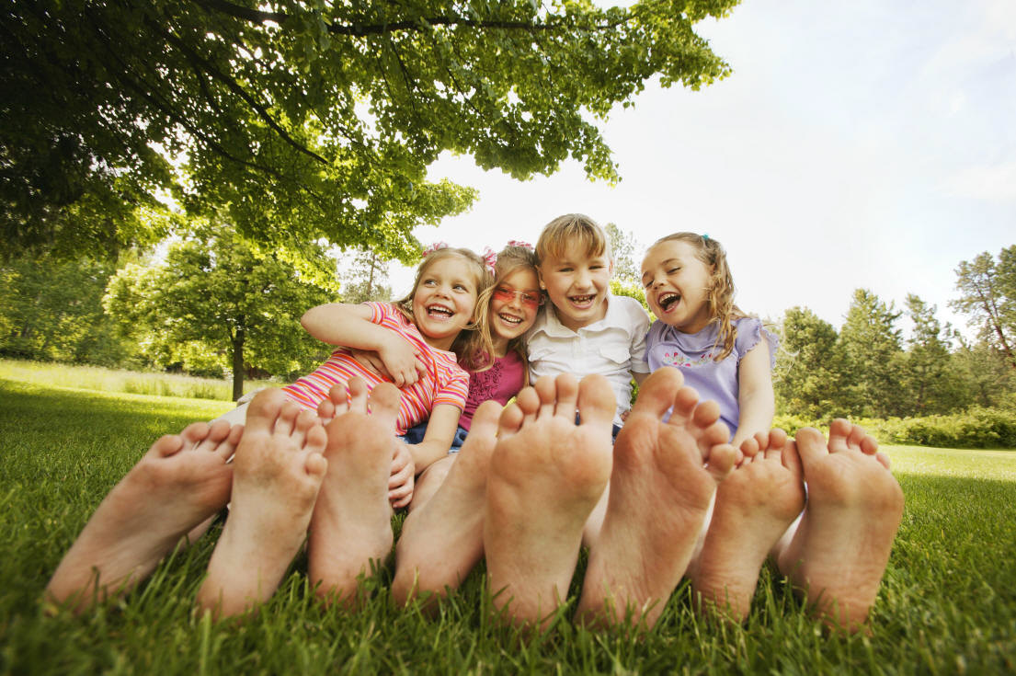

Do you have questions, comments, or other information?

Please Feel Free to Call:

Jenifer Barefoot Hixenbaugh, Owner/Director

(cell) 757-449-3479

Revised January 2021

*Translations made upon request.*